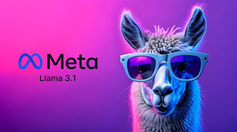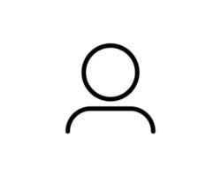

LLaMA prompt: Listing 4

LLaMA prompt: Listing 2

LLaMA prompt: Listing 1

Risky clauses

LLaMA prompt: Listing 3

Regulations

Gold standard contract

**Database**Contains gold standard contracts, state-level regulation documents, examples of risky clauses

Database

**Back-end: Python**Uploaded contract compared against stored documents/text using LLaMA prompts

Back-end

**Front-end/User Interface: HTML, CSS, Javascript**Contract uploaded to be analyzed, Analysis returned

User Interface